



Carefully fish in the post-wartime lakes of Brenex, filled with fish and nuclear bombs, to try and feed your village – but be quick! You’re not the only one who had the same idea, and the best fisher gets to take the most food home to their family.

**Features**



Fish with your friends in this twist of the classic puzzle game ‘Minesweeper’, where every player fishes on the same board!



Search for fish by clicking on a spot on the Lake



Don’t just pick any random spot to fish: if you find a bomb, it will explode – killing you instantly – and take out some of the fish you already caught with you!

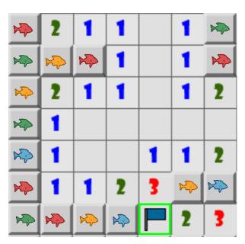

Use the hints left by long-gone fishers to find where bombs are located and avoid them.



After a bomb explodes, the remaining fishers still have a few minutes to fish until the radiation kills them.



Every fisher has flags they can place on a fishing spot if they think it hides a bomb. Fishers can see each other’s flags – but careful! Other players may flag the wrong spot to trick you!



Fish enjoy the warmth of radiation: the more bombs there are around a fishing spot, the more fish you will find.



The more fish you catch, the more you get to take home and the higher your score will be!





Don’t worry: all the fish you have with you by The End will revert to your village and families – whether you’re dead or alive!

**Overview**

* People fishing in a post-war country.
* Players that enjoy parallel play
* Players that enjoy puzzle-solving
* Players that enjoy casual competition

**Target Audience**

* Fish to feed your village and starving family (PS4’s just aren’t as good as sardines, after the price of fish went up).
* Hone your strategy and problem-solving skills in casual competition.
* Be a faster fisher than your friends – or flag the wrong spot to sabotage them.
* Make a multiplayer version of Minesweeper that is both fun and balanced.
* Comical: design, sound effects, and setting contribute to comedic aspect of the situation.

**Design Goals**

**Target Hardware**

* PC

**Unique Selling Points**

* Puzzle-solve as team.
* A twist on an old favorite:
  + What used to be a solitaire game can now be shared between friends and family.
* Minesweeper Versus
* Minesweeper

**Competition**

* Puzzle
* Multiplayer

**Genre**

**Player Motivation**

**Theme**